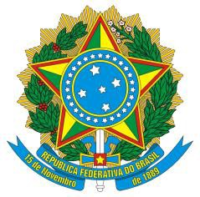
Permanent Mission of Brazil to the United Nations Office
and other International Organizations in Geneva

Brazil welcomes the delegation of South Sudan to the UPR. In light of current challenges, Brazil recommends that South Sudan:
(i) guarantee effective delivery of humanitarian assistance to civilians and protection of humanitarian actors, with full respect for international humanitarian law, while stepping up its cooperation with the Human Rights Division of the United Nations Mission in South Sudan (UNMIS), in particular concerning the implementation of the Cessation of Hostilities Agreement of January 2014;
(ii) promptly address the impact of the conflict on civilian access to food, including through concrete steps in technical assistance and capacity building, as requested in the national report.
Brazil is particularly concerned about impunity and lack of accountability for serious crimes and human rights violations in the country and reiterates the need to create means to establish the independent hybrid court and a commission for truth, reconciliation and healing consistent with the Agreement on the Resolution of the Conflict.
Brazil would like to place on record its appreciation for the South Sudanese government cooperation with regional and multilateral fora and its willingness to implement the Agreement on the Resolution of the Conflict in South Sudan, while stressing the need to immediately stop any actions that may cause restrictions and other impediments to humanitarian aid.
Last but not least, Brazil encourages South Sudan to continue to actively pursue cooperation, with the decisive support of the UN, the African Union and the international community at large.

